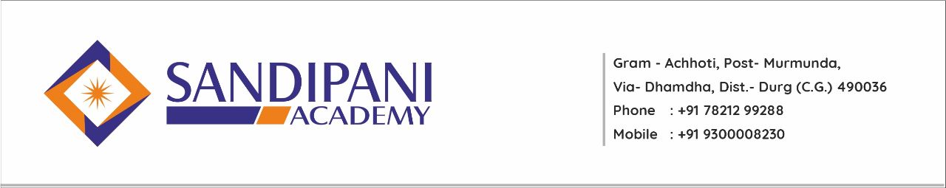
S.NO. | PROGRAM NAME | MONTH | DATE
1. | Innovation in E-Learning & Learning Management System | July | 08/07/2021
2. | Imbibing Integral Education in New Education Policy | August | 16/08/2021
3. | Professional Ethics | October | 09/10/2021
4. | Research Methodology & IPR | December | 29/12/2021
5. | Managing Inner Harmony for Better Teaching Learning | February | 26/02/2022
6. | Basic Etiquettes & Manners | July | 20/07/2022
7. | Growing Within | November | 19/11/2022
Faculty Development Program

